

UKG Open Enrollment Reference Guide 2027

Please keep in mind that this year is a passive enrollment. Employees who do not need to make any adjustments to their 2026 elections do not need to actively enroll. Only employees that are making changes to their election, electing for the first time, and making 2027 FSA elections, will be required to make an active election.

For employees with a Springpoint email address

Please log onto the UKG website: https://springpoint.ukg.net .

On the login screen, there is a clickable button to sign in using “SSO.” Please click that button. SSO means Single Sign On.
On the next screen, you will be prompted for a password. Please enter the same password as you use to sign on to your work account/computer.

You will be prompted through MFA steps for security purposes.

For employees without a Springpoint email address

Please log onto the UKG website: https://springpoint.ukg.net.

On the login screen, your username is your last name and first initial. The default password is set to your birth date, for example 01012024. At this point, you will be prompted to reset your password.
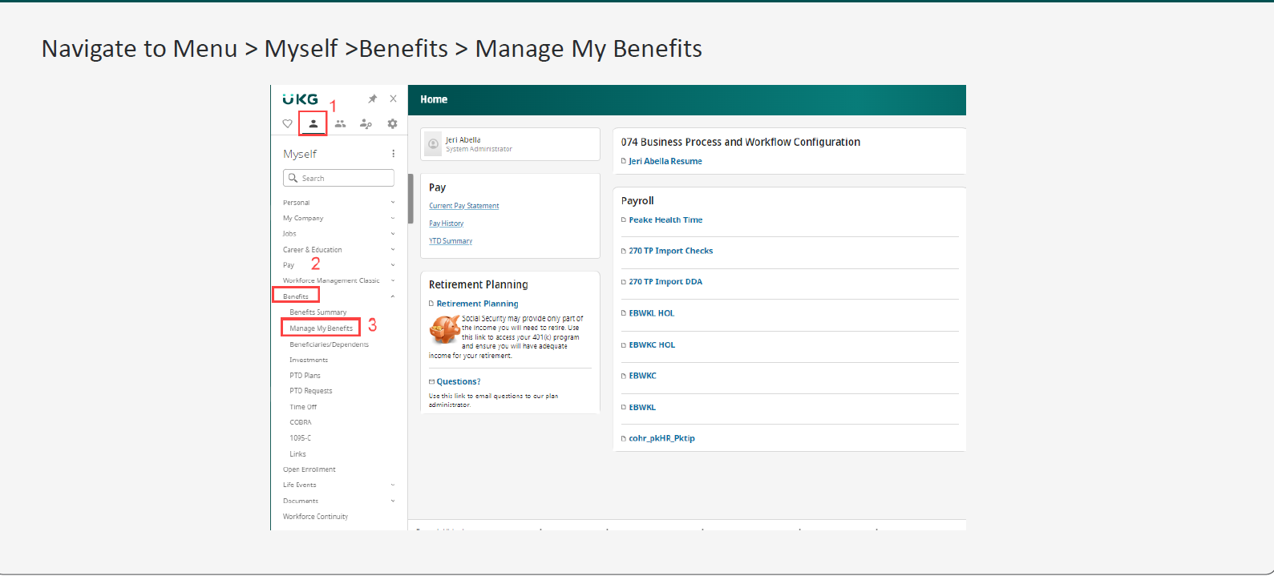

On the landing page, Get Started

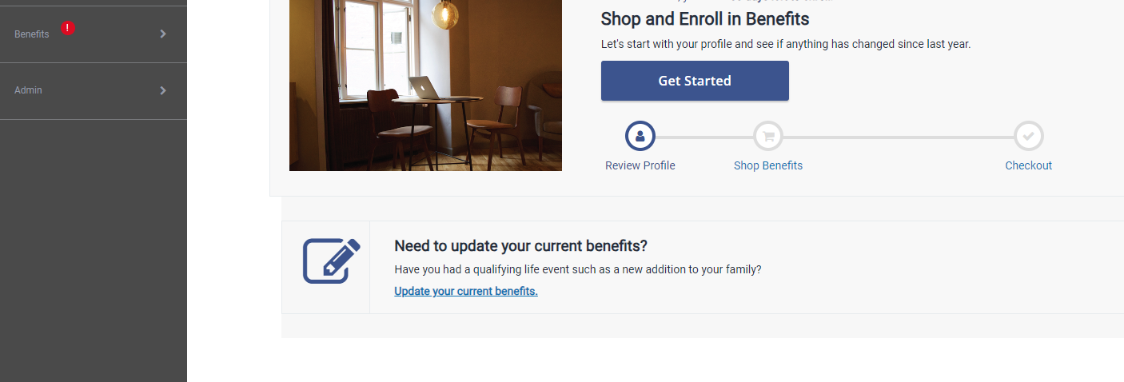

Things to Note

- You will need to have Social Security Numbers available for all your dependents to enroll in medical, dental and vision.
- If you would like to change your current benefit, you will need to locate the benefit you would like to update and click on View or Change to update the benefit.
- FSA needs to be elected every year. The maximum for 2027 is $3,400.
- Please review your beneficiaries for accuracy.
- If you choose to elect additional Supplemental Life, since we are changing carriers, you will be allowed to elect up to $80K with no EOI. Any amount above this will require an EOI to be completed, once approved, you will be notified and UKG will be updated accordingly. If you are electing LTD for the first time you will not need to provide a completed EOI form for approval. If you have an existing LTD policy the policy will roll over to the 2027 plan year.

The screen shot below is an example of an employee enrollment that has active benefits in Benefits Administration. The benefits that require an active election would display the Shop Plans election and the benefits that are passive have the View or Change tab.

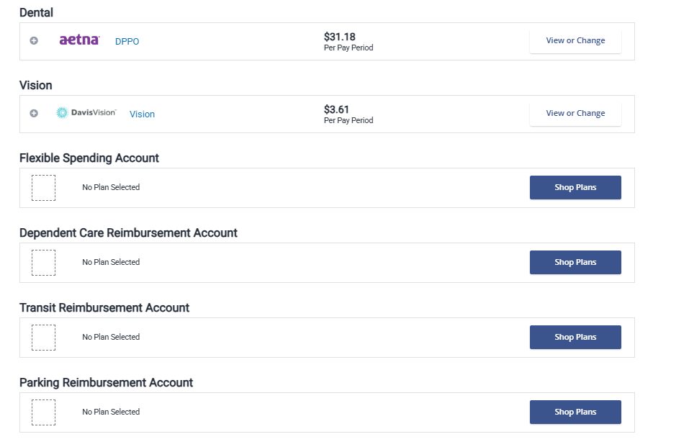

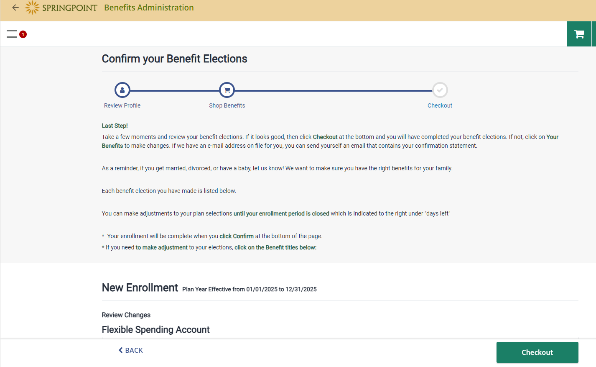

Please verify that you click the Checkout tab.

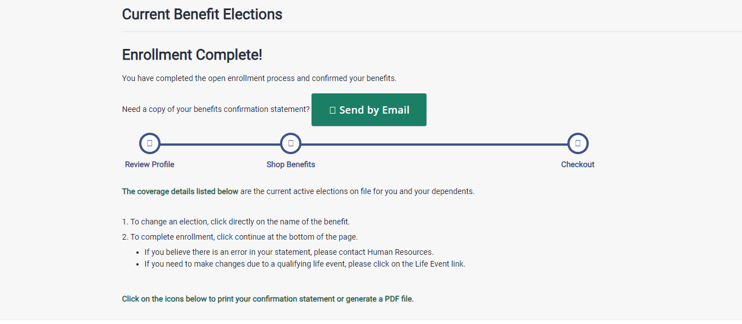

The confirmation page notifies that your enrollment is completed.

If you have any questions or need assistance, please contact your Human Resources Representative.

